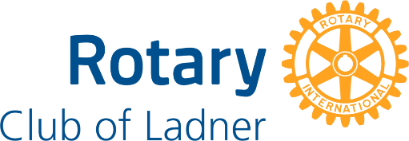

FACT SHEET ROTARY CLUB OF LADNER
Rotary unites women and men from all continents and cultures who take action to deliver long-term solutions to our world’s most persistent issues. In communities across the globe, our 1.2 million members come together to strengthen their connections to friends and neighbors and their commitment to improving lives.
While our 45,000 clubs all share a commitment to community service, the experience, focus and dynamics of each club is unique. Becoming a Rotary member connects you with a diverse group of professionals who share your drive to give back.
Causes: Solving real problems takes real commitment and vision. Each year, Rotary members raise funds and donate countless volunteer hours in sustainable, community-based solutions to promote health, peace, and prosperity in communities across the globe.
Recent Rotary Club of Ladner Projects
Local | International
Splash Park – Ladner | Atlantis South Africa school garden project  Water Filters - Laos
E-bike charging stations - Ladner | Polio eradication campaign
Christmas Dinner – Adult special needs group | School support Mexico
Interact youth group – Delta Secondary School | Shipping humanitarian health & education supplies
School Scholarships.

History: Rotary members have been addressing challenges around the world. It started with the vision of one man — Paul Harris. The Chicago lawyer formed the Rotary Club of Chicago on Feb. 23, 1905, so professionals with diverse backgrounds could exchange ideas, form meaningful, lifelong friendships, and give back to their communities. The Rotary Club of Ladner has served the community since 1957.
The Rotary Club of Ladner is a community service club whose members are attracted by the opportunity to serve the community, providing personal rewards through service and fellowship. Membership represents a broad cross-section of community members. Individuals in our organization represent professions in law, finance, education, retail, communications, retirees, not-for-profit and public service. As a club of community leaders and concerned people, Rotary offers a unique opportunity to help citizens in our community as well as people, internationally.
Benefits of Rotary Service – Members feel good about giving back and using their talents for humanitarian service both locally and internationally. Rotary offers the opportunity to use those skills for the betterment of the community and the world. Rotary allows club members to enlarge their circle of business, professional and community connections. Rotary offers a variety of online and in person courses that benefit members professionally and support Rotary service.
Rotary meetings are an opportunity for friendship, networking and to engage with speakers from various organizations and groups. The Rotary Club of Ladner meets on Tuesday at noon at the Coast Tsawwassen Inn, 1665 56 St, Delta, BC V4L 2B2. Members are encouraged to regularly attend meetings and social events. However, there is no minimum attendance requirement.
Please visit our website at www.Rotary-Ladner.org or contact us at info@Rotary-Ladner.org

